M1
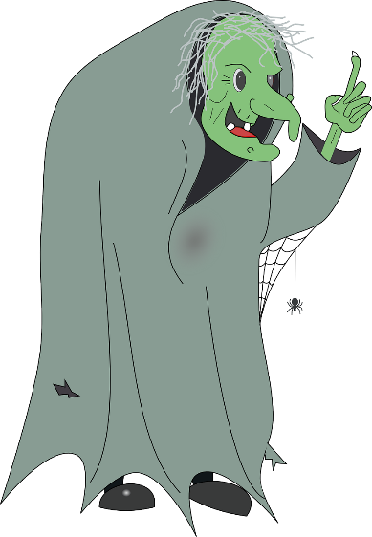
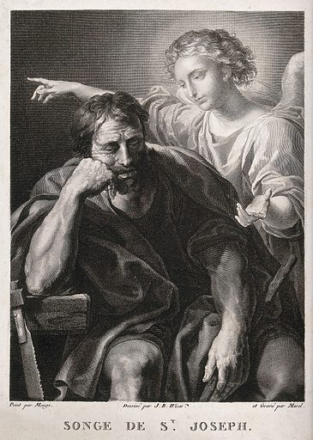
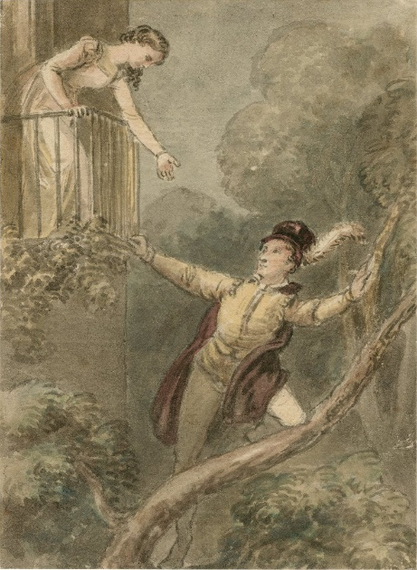
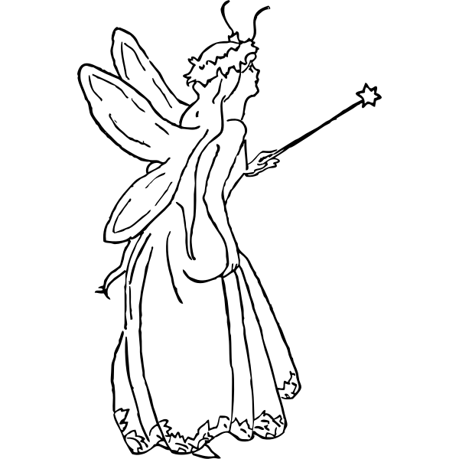
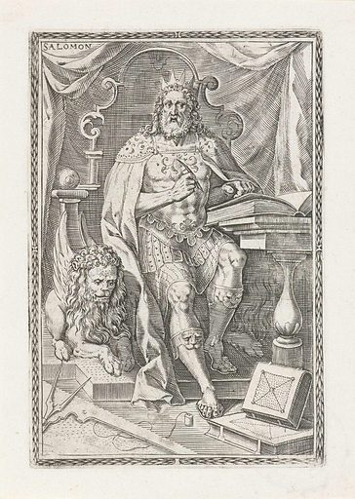
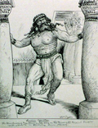
DELILA
MULAN
MOSTOHA
JÓTÜNDÉR
RÓMEÓ
JÓZSEF
MÁRIA
SÁMSON
JAMES BOND
SALAMON

Képek forrásai:
Sámson: https://cdn4.picryl.com/photo/1880/01/01/samson-agonistes-640.jpg
James Bond: https://www.maxpixel.net/static/photo/1x/Agent-Bow-Tie-James-Bond-Black-Suit-2026107.png
Salamon: https://www.lookandlearn.com/history-images/preview/YR/YR0/YR0168/YR0168284_King-Solomon.jpg
Rómeó: https://upload.wikimedia.org/wikipedia/commons/6/68/Act_II_Scene_ii_%E2%80%93_Juliet_on_the_Balcony.jpg
József: https://www.lookandlearn.com/history-images/preview/YW/YW034/YW034598V_The-angel-speaks-to-Joseph-in-a-dream.jpg
Delila: https://upload.wikimedia.org/wikipedia/commons/1/1e/Book_of_Judges_Chapter_16-3_%28Bible_Illustrations_by_Sweet_Media%29.jpg
Mária: https://freesvg.org/img/Christmas.png
Mulan: https://cdn.pixabay.com/photo/2017/04/28/01/06/disney-2267119_1280.png
Mostoha: https://cdn.pixabay.com/photo/2013/07/12/14/33/witch-148439_1280.png
jóságos tündér https://freesvg.org/img/johnny_automatic_fairy_queen.png

