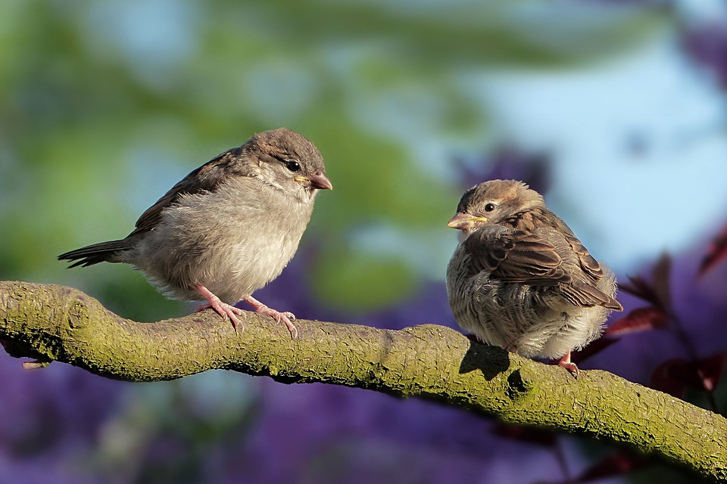M3 – VEREBEK
forrás: https://pixabay.com/hu/photos/verebek-madarak-%c3%bcl%c3%a9s-sperlingek-3434123/

