- melléklet: Online feladatok

https://wordwall.net/hu/resource/25415460

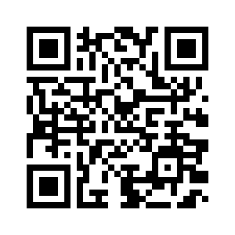

https://wordwall.net/hu/resource/25415790

