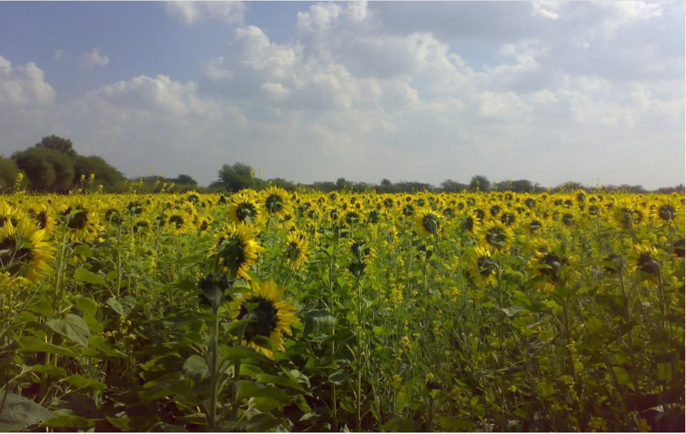
https://freerangestock.com/photos/4730/sunflower.html

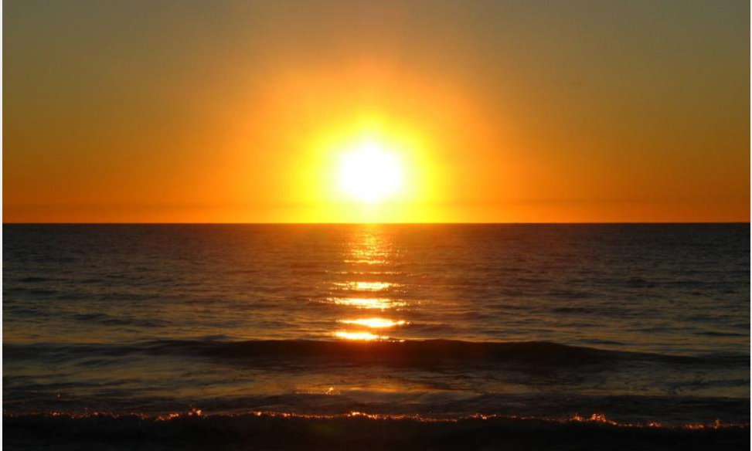
https://freerangestock.com/photos/32180/an-ocean-sunset-landscape.html
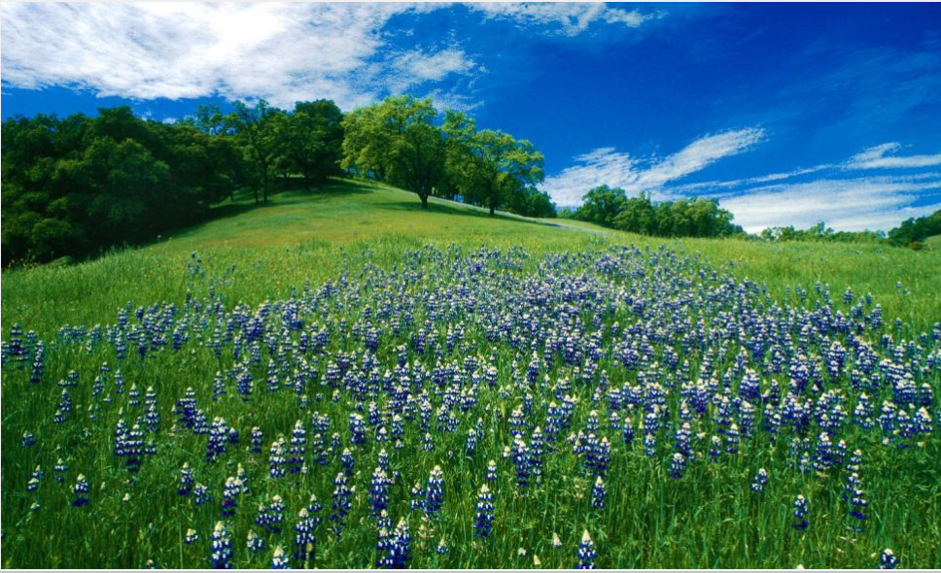
https://freerangestock.com/photos/1759/rolling-hills-with-blooming-lupin.html
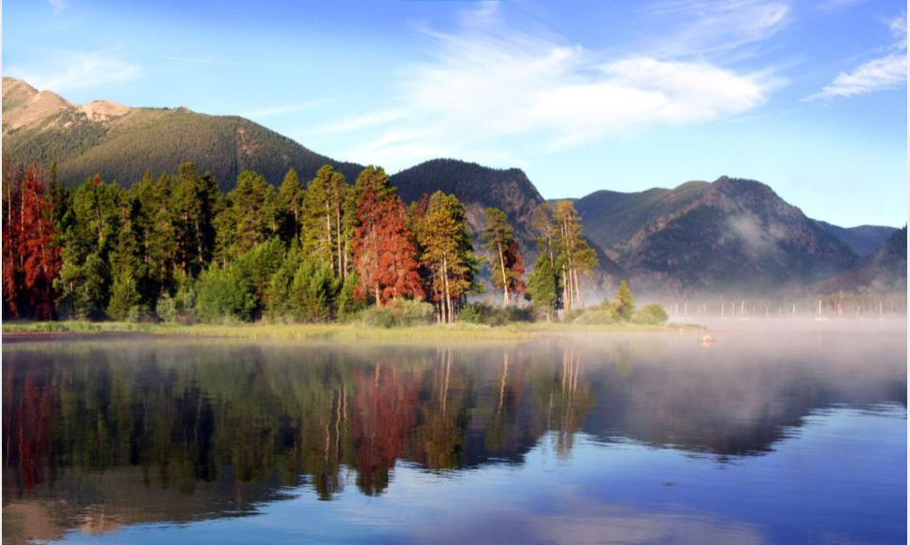
https://freerangestock.com/photos/5970/dillon-lake.html
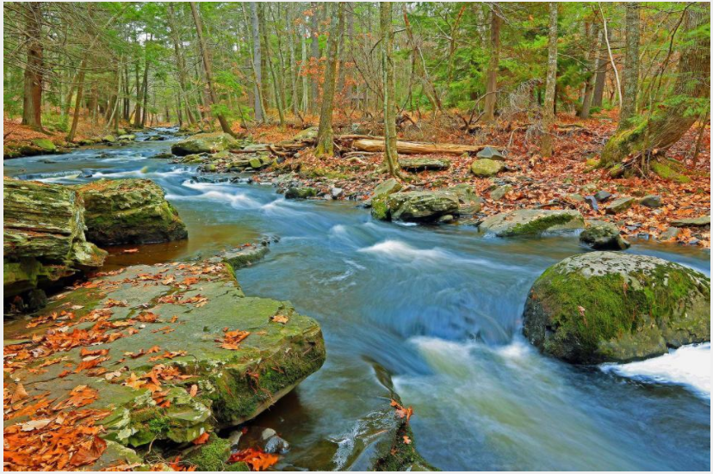
https://freerangestock.com/photos/58147/water-ripples-of-a-brook-.html
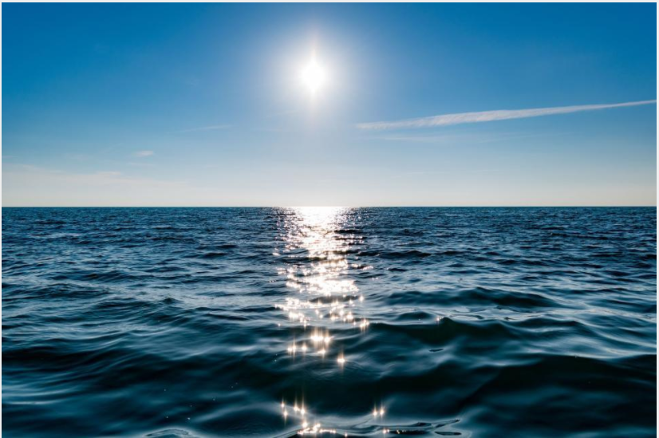
https://freerangestock.com/photos/125568/sun-light-reflection-on-ocean-water-.html
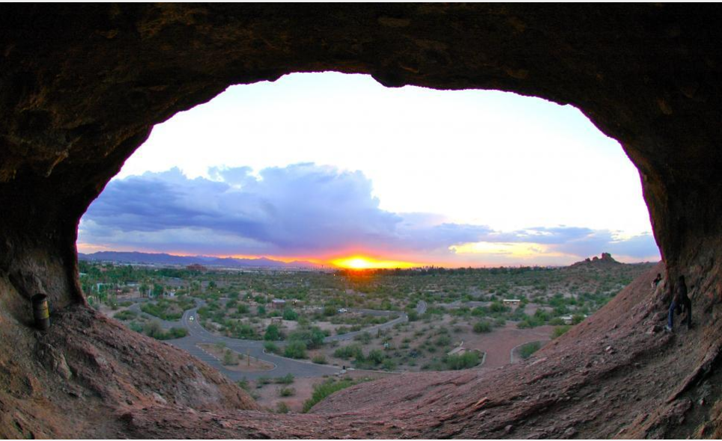
https://freerangestock.com/photos/27038/sunset-through-natural-bridge-arch.html
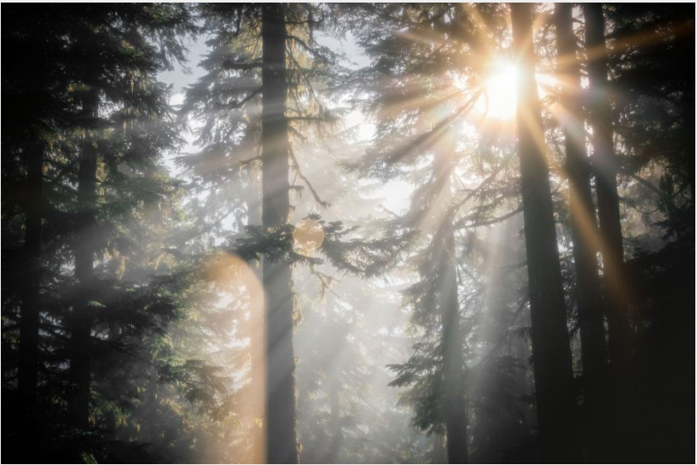
https://freerangestock.com/photos/141345/sun-shining-through-forest-trees.html

