Bilder zur Gruppenbildung

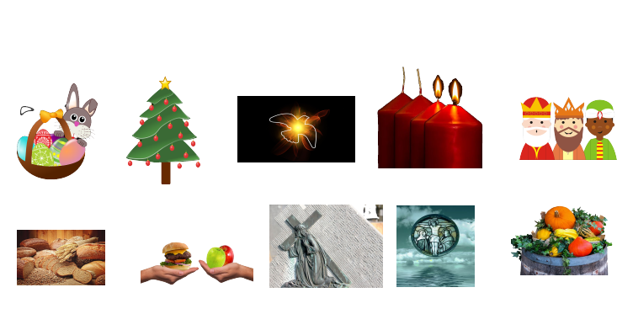

Laufzettel
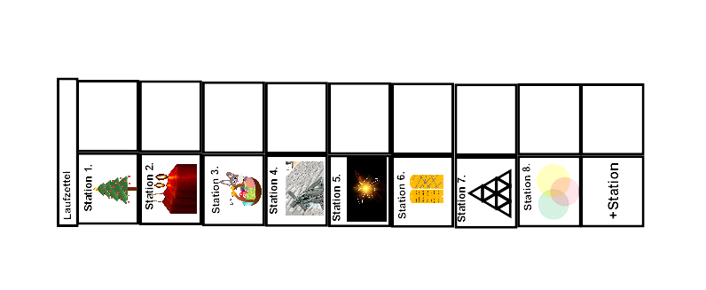

Aufgabenblatt zum Ausfüllen
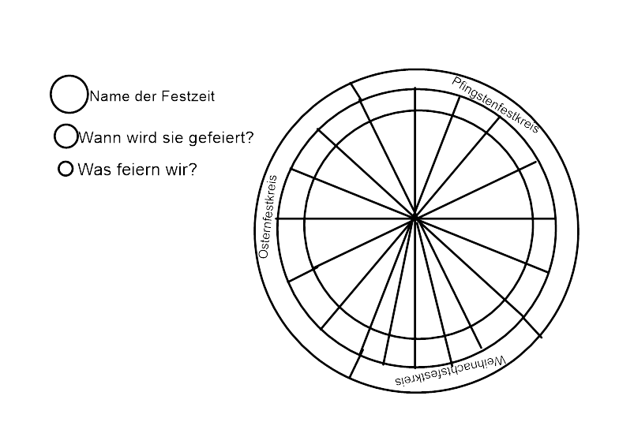

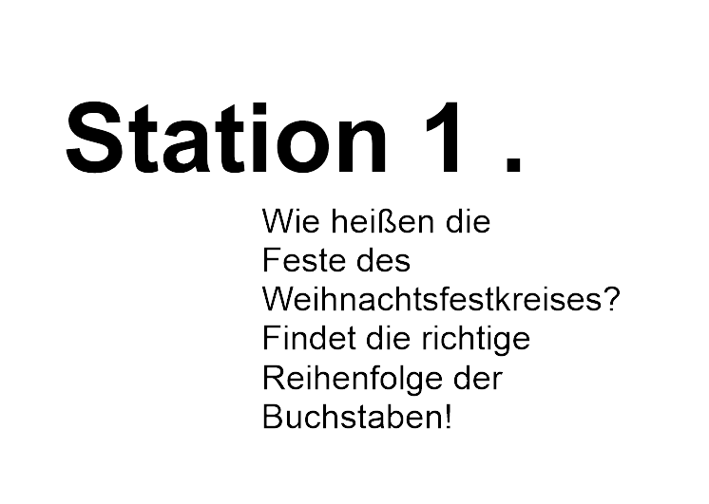

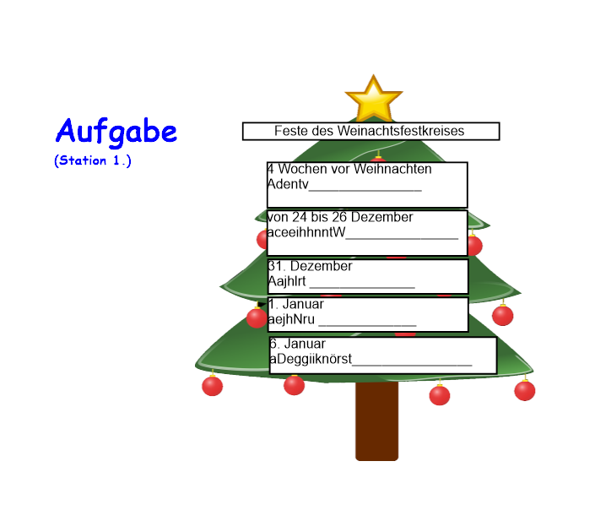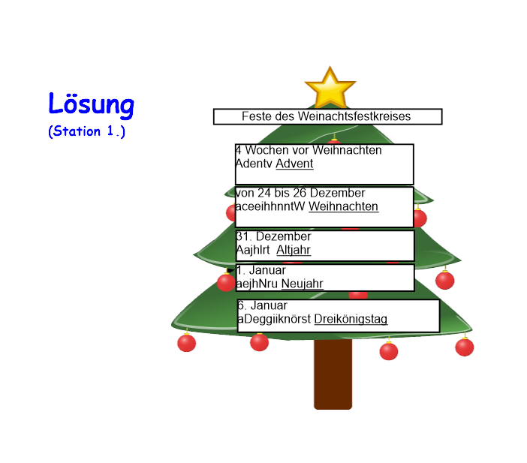

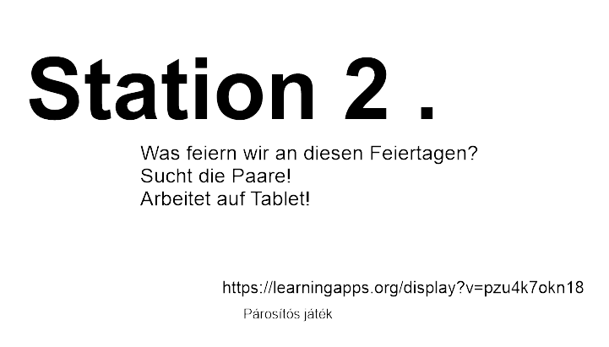

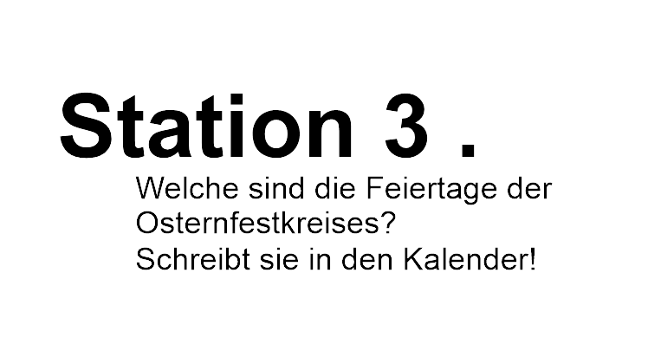

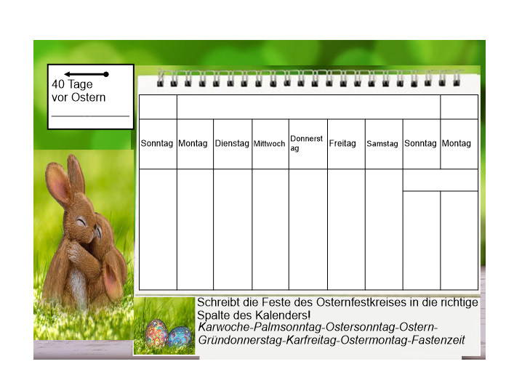
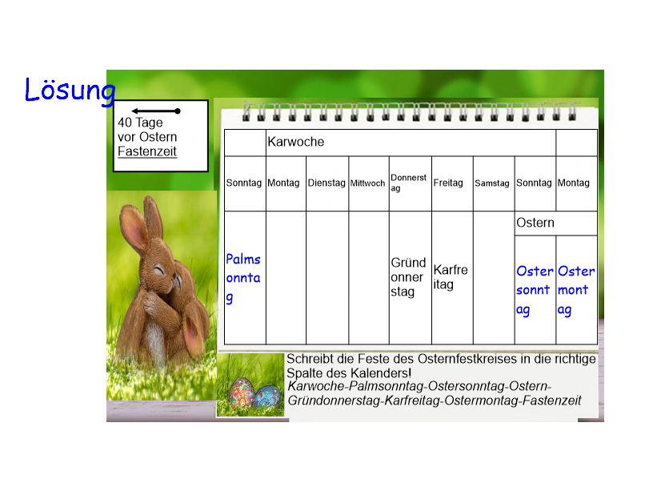

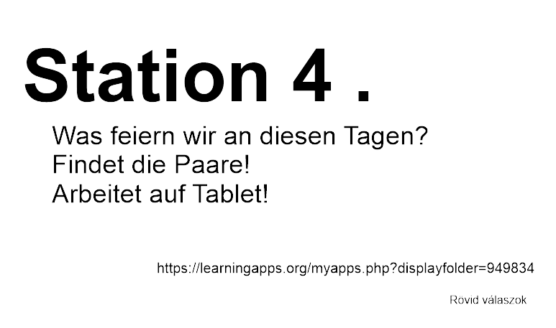

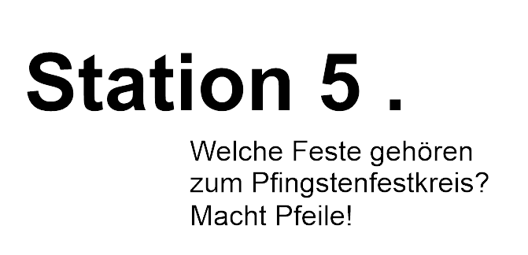

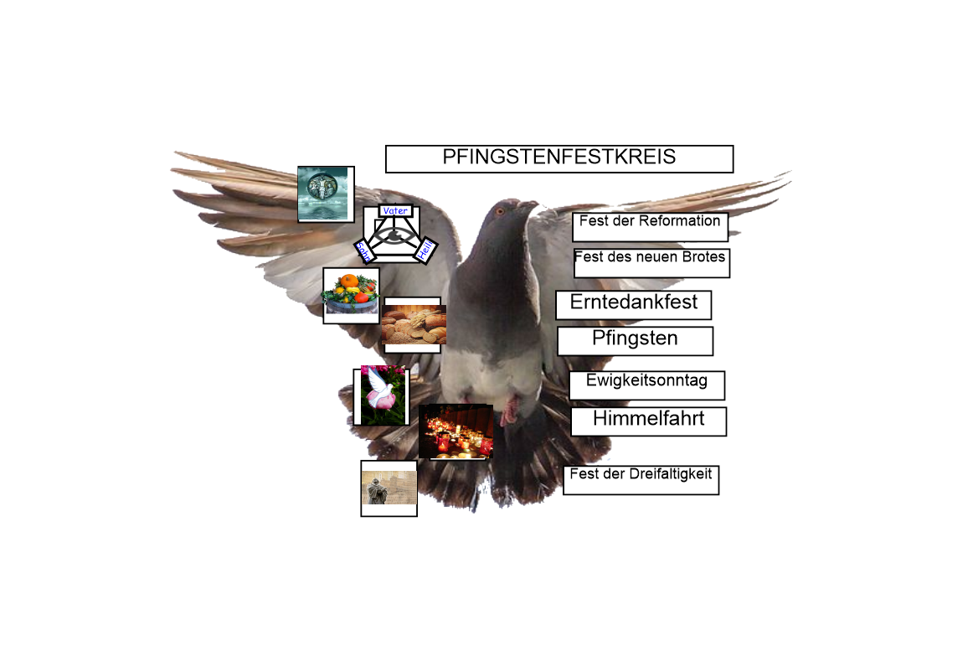
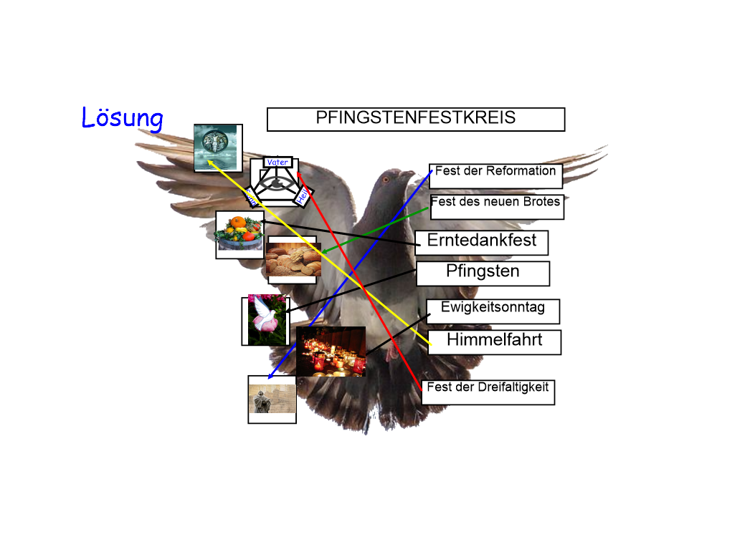

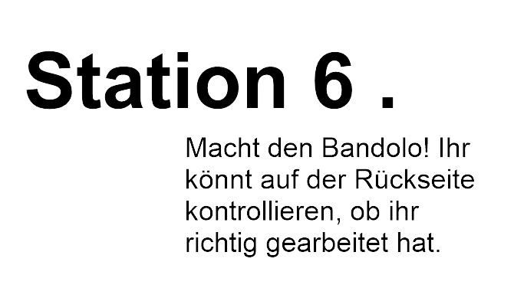

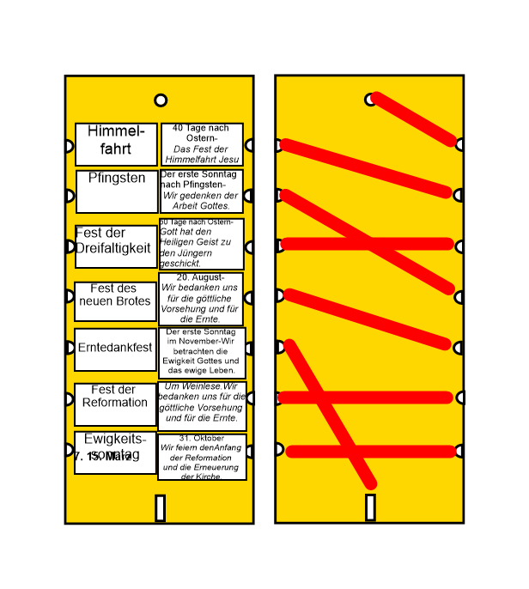

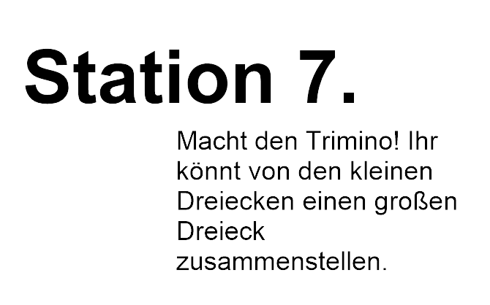

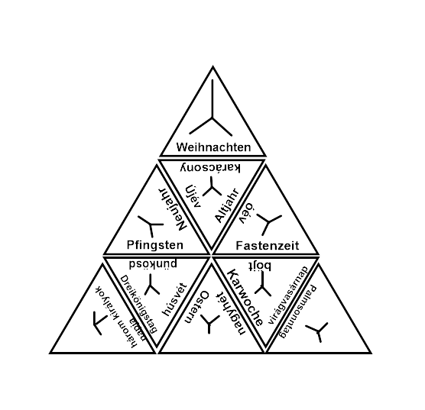

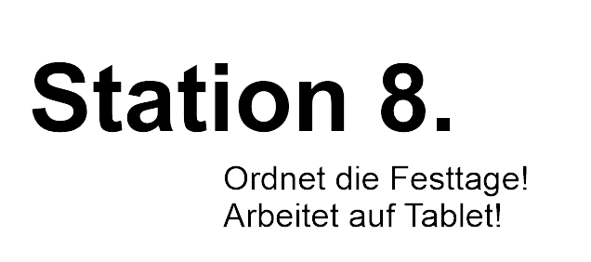

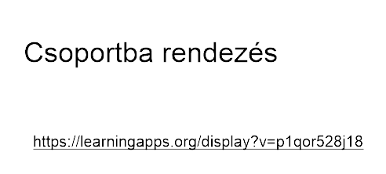

+ Station
Wenn du noch Zeit und Lust hast, kannst du ein Mandala wählen und malen.

Kostenlose Mandalas:
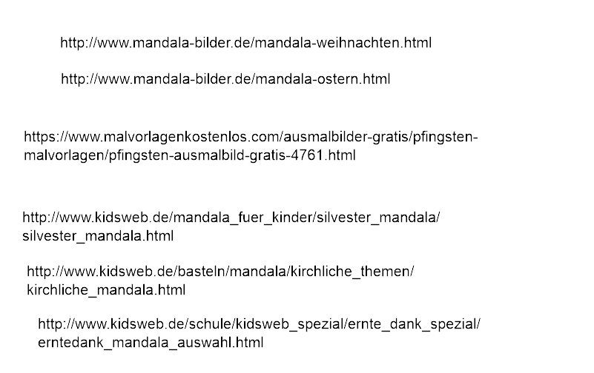
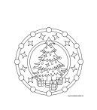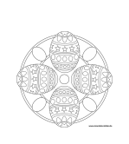

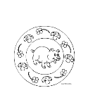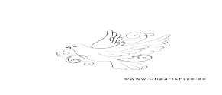

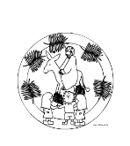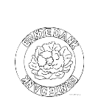
https://hu.wikipedia.org/wiki/Kereszt%C3%A9ny_egyh%C3%A1zi_napt%C3%A1r
https://pixabay.com/en/easter-bunny-eggs-nest-basket-154403/
https://pixabay.com/en/christmas-tree-plant-decorated-23384/
https://pixabay.com/en/pentecost-dove-holy-spirit-3409407/
https://pixabay.com/en/advent-advent-candles-1883840/
https://pixabay.com/en/bible-cartoon-comic-1706771/
https://pixabay.com/en/bread-candy-pies-2864703/
https://pixabay.com/en/eat-food-remove-almost-time-3236971/
https://pixabay.com/en/jesus-christ-cross-cross-carry-1248835/
https://pixabay.com/en/cross-christ-sea-redeemer-faith-2744229/
https://pixabay.com/en/nature-harvest-autumn-agriculture-2657801/
https://pixabay.com/en/easter-easter-bunny-hare-spring-3204589/
https://pixabay.com/en/flower-blossom-bloom-bloom-rose-2370947/
https://pixabay.com/en/dove-peace-flying-freedom-41260/
https://pixabay.com/en/day-of-the-dead-candles-people-204539/
https://pixabay.com/en/pigeon-dove-bird-wings-fly-747462/
https://pixabay.com/en/luther-martin-luther-wittenberg-1821759/
https://pixabay.com/en/lims-laboratory-information-1604450/

