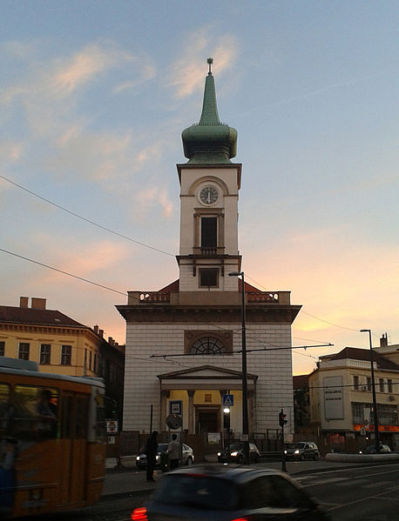
https://hu.m.wikipedia.org/wiki/F%C3%A1jl:Reform%C3%A1tus_templom_(1041._sz%C3%A1m%C3%BA_m%C5%B1eml%C3%A9k).jpg

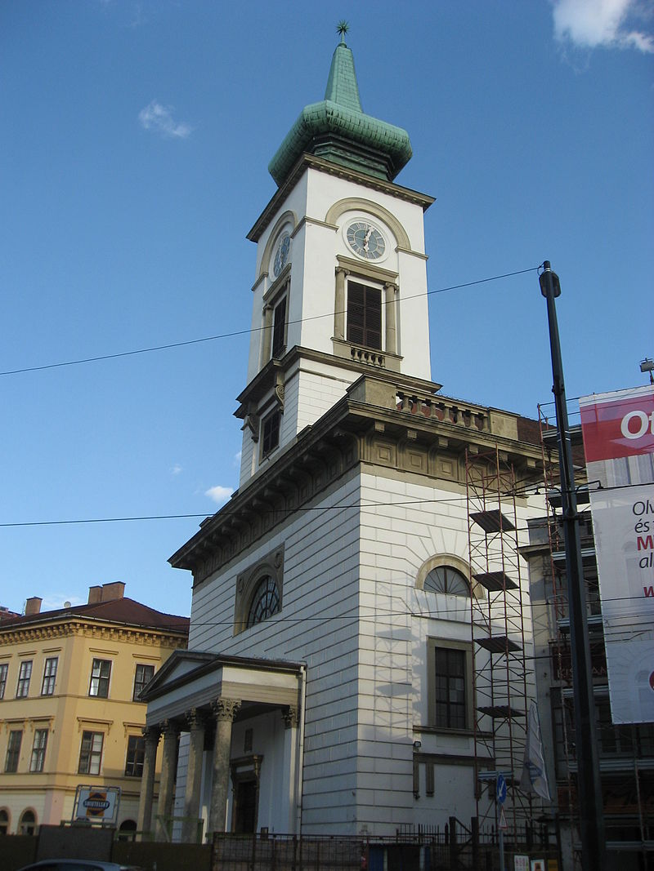
https://hu.wikipedia.org/wiki/Szerkeszt%C5%91:Einstein2/Budapest/Arch%C3%ADvum#/media/File:Budape%C5%A1%C5%A5_1248.jpg

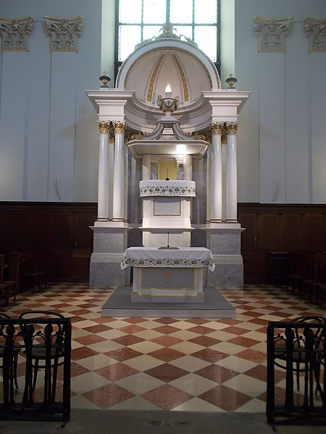
https://commons.wikimedia.org/wiki/File:K%C3%A1lvin_Square_Reformed_Church,_pulpit,_2017_Ferencv%C3%A1ros.jpg

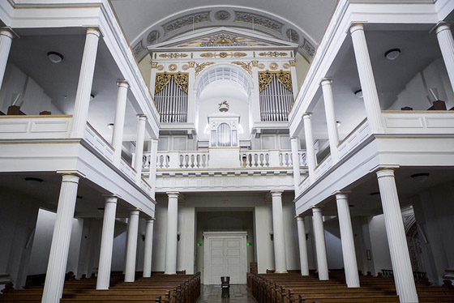
http://www.ferencvaros.hu/index0.php?name=hir_150904_KalvinOrgona

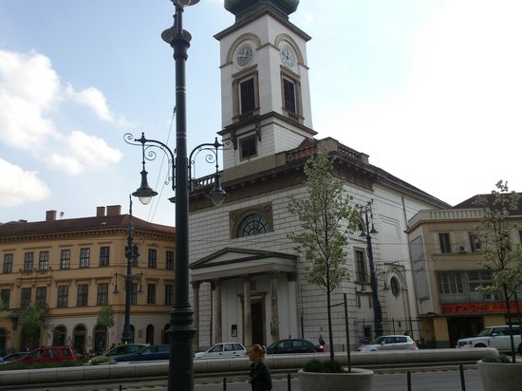
https://www.tripadvisor.co.hu/LocationPhotoDirectLink-g274887-d785278-i97092711-Pata_Negra_Pest-Budapest_Central_Hungary.html

