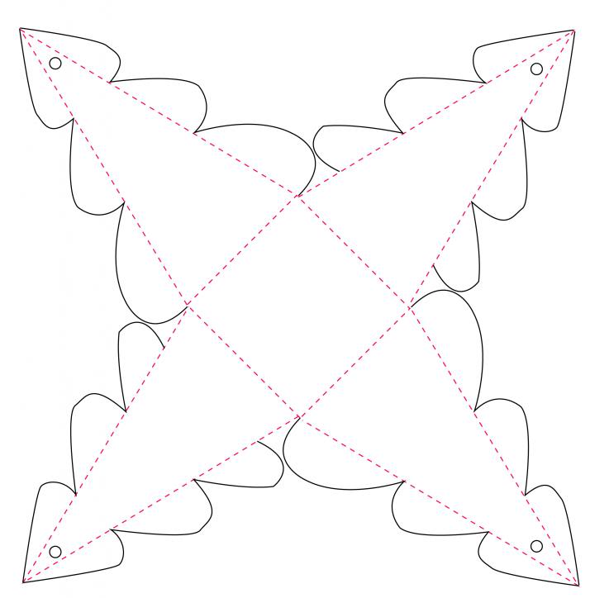

http://photobucket.com/gallery/user/Trimcraftltd/media/cGF0aDpUcmltY3JhZnQgVGVtcGxhdGVzL0RheV8xMl90cmVlX2JveF96cHNkMzI4M2EzMi5qcGc=/?ref=

