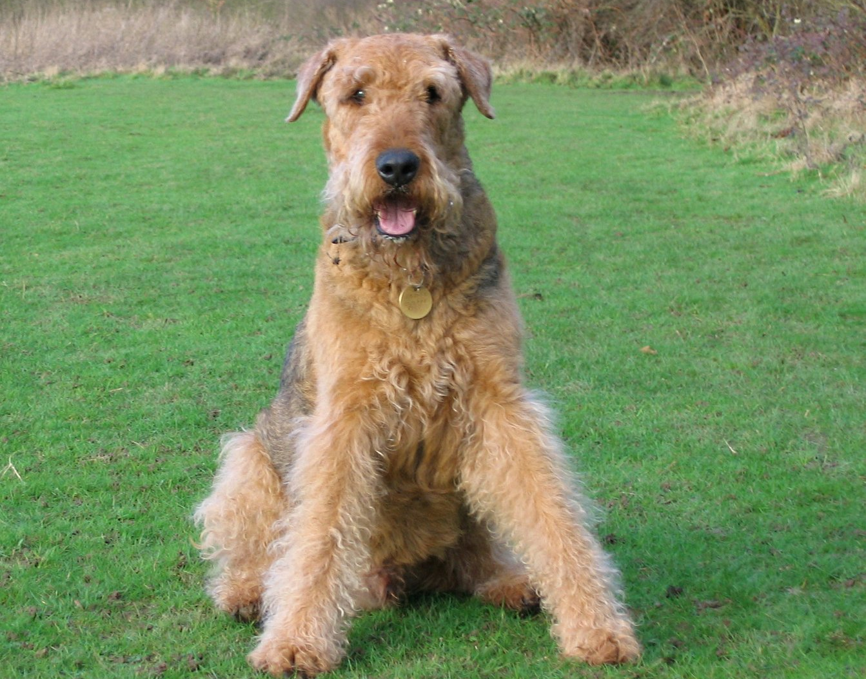
https://www.freeimages.com/photo/airedale-terrier-1406158
hanganyag:
https://www.youtube.com/watch?v=8oavDnnkXxk

https://www.freeimages.com/photo/airedale-terrier-1406158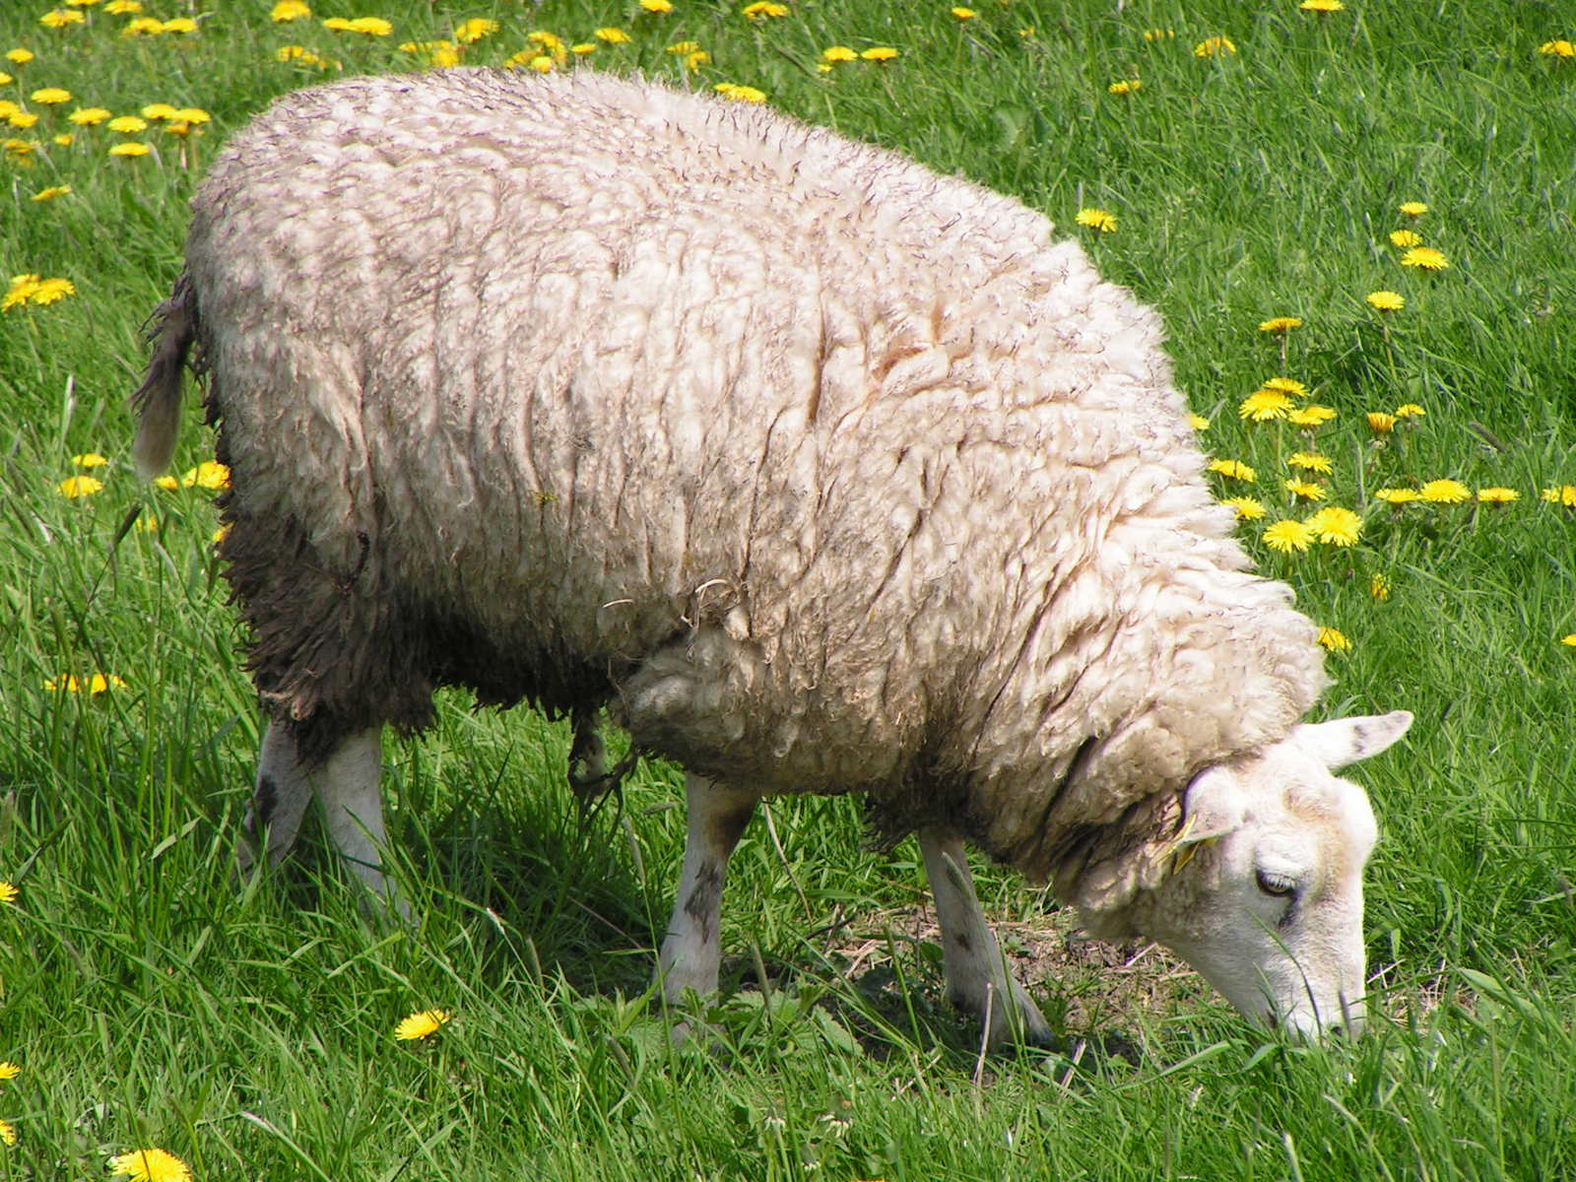
https://www.freeimages.com/photo/cow-and-sheep-1397891

hanganyag:

https://www.youtube.com/watch?v=x3c0JgZ59QQ

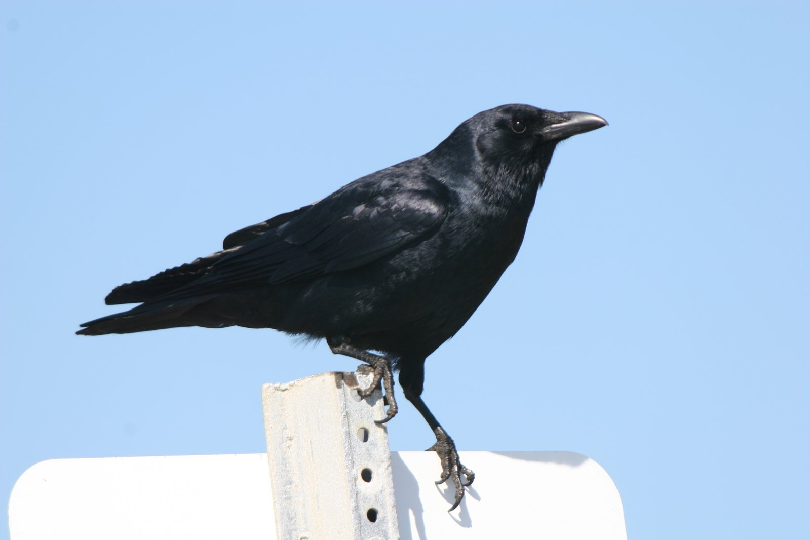
https://www.freeimages.com/photo/crow-1400410
hanganyag:
https://www.youtube.com/watch?v=iL9C3oxmcas
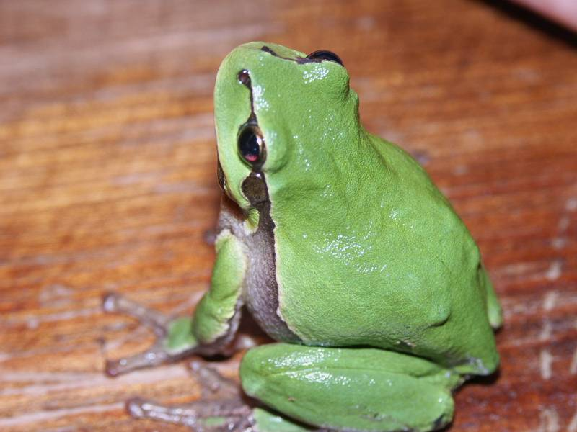
https://www.freeimages.com/photo/frog-1542791
hanganyag:
https://www.youtube.com/watch?v=UiidibfhidE
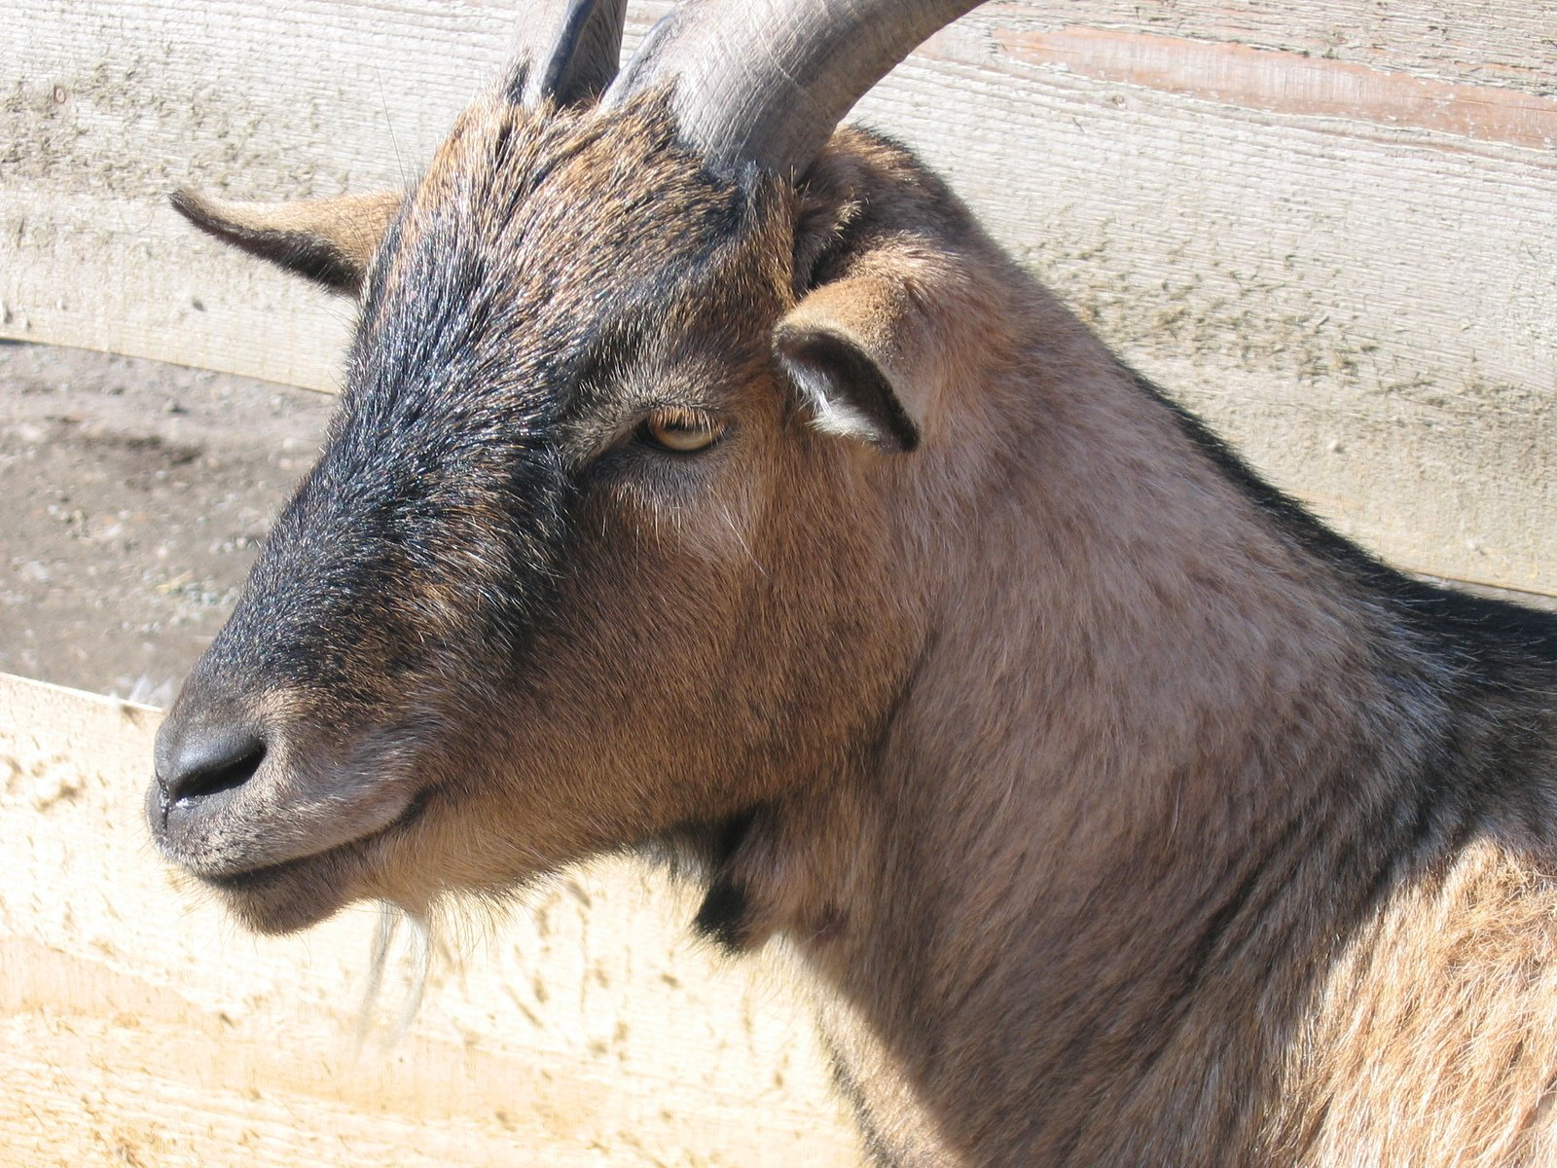
https://www.freeimages.com/photo/goat-1375893
hanganyag:
https://www.youtube.com/watch?v=ZIzvvFpgk8E
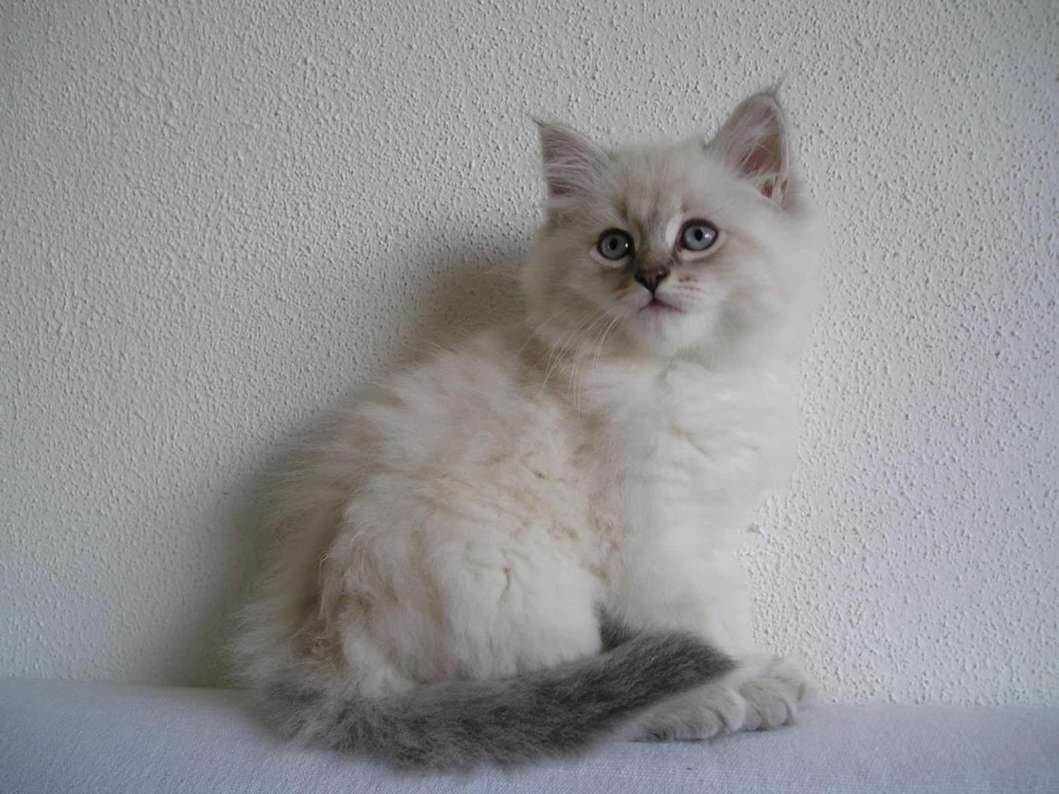
https://www.freeimages.com/photo/neva-masquerade-kitten-ilarion-5-1058056
hanganyag:
https://www.freeimages.com/photo/goat-1375893
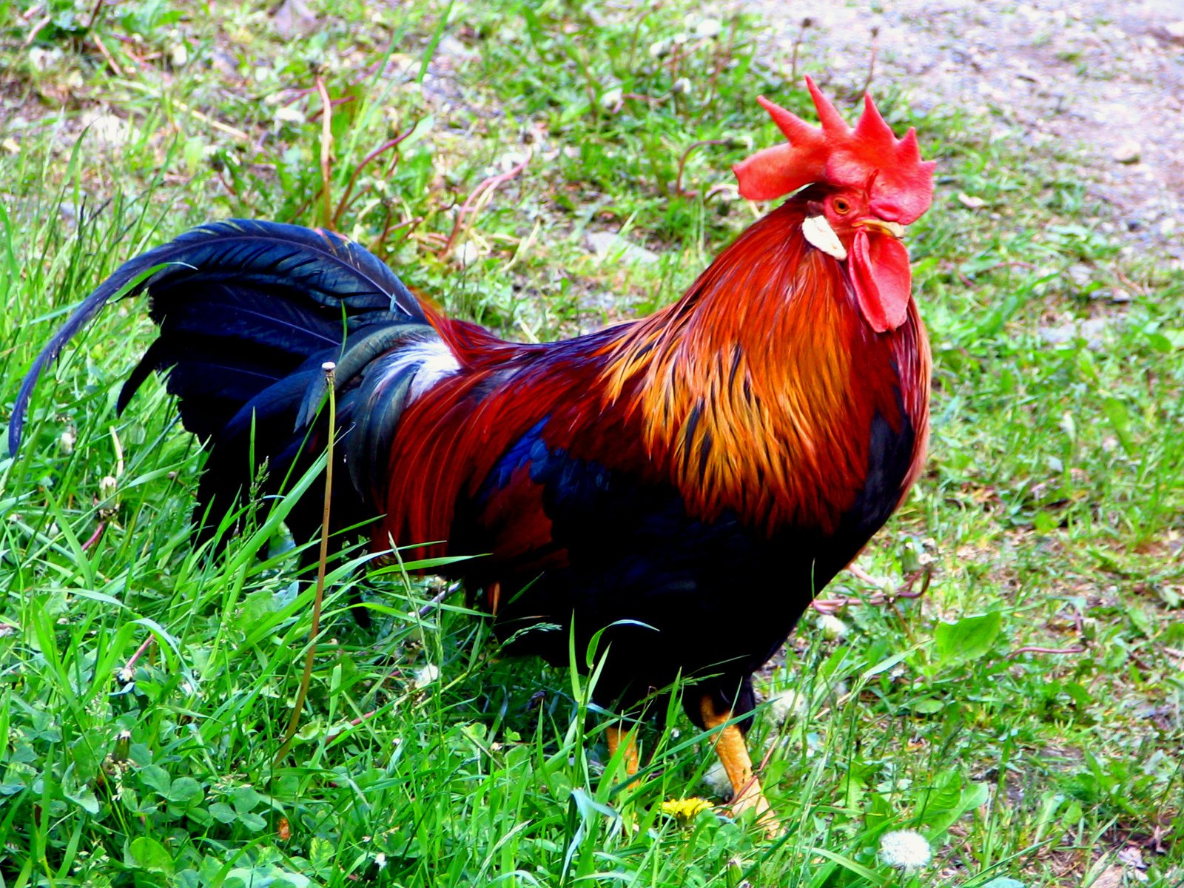
https://www.freeimages.com/photo/nicecoloured-rooster-1546519
hanganyag:
https://www.youtube.com/watch?v=T1v7aXMe6bc
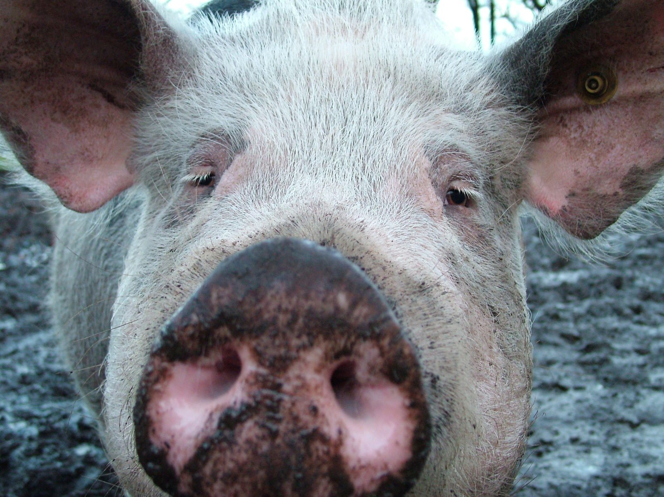
https://www.freeimages.com/photo/the-pig-1405070
hanganyag:
https://www.youtube.com/watch?v=Bg2BlPy1I30

