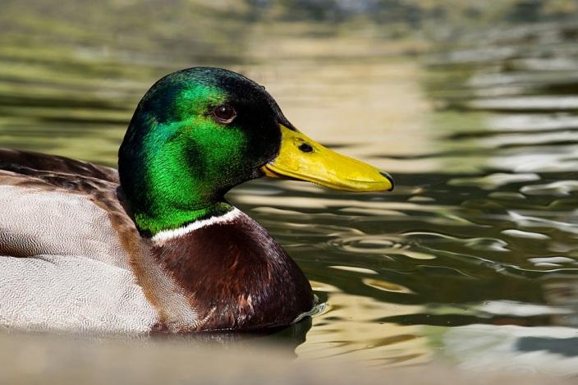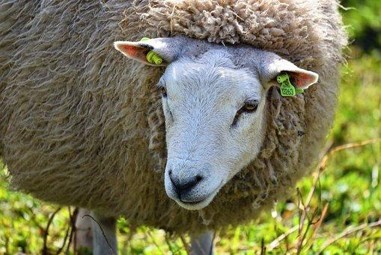

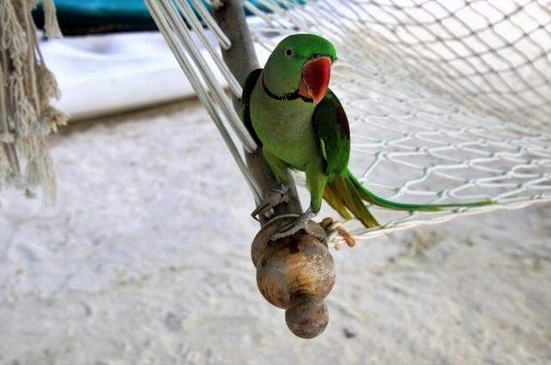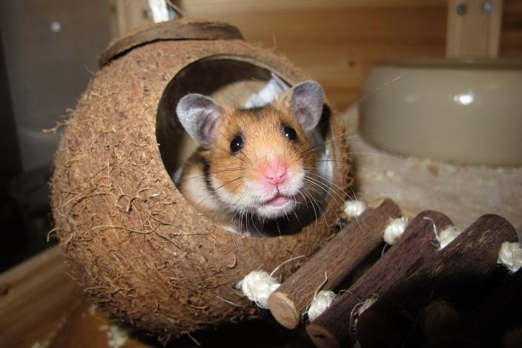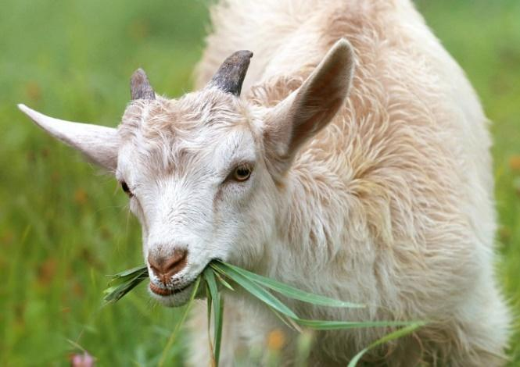

Képek forrása:
https://pixabay.com/hu/juh-%C3%A1llati-eml%C5%91s-k%C3%A9r%C5%91dz%C5%91-3294843/
https://pixabay.com/hu/mallard-r%C3%A9ce-anas-platyrhynchos-3442870/
https://pixabay.com/hu/kecske-b%C3%A1r%C3%A1ny-kis-f%C5%B1-farm-falu-1596880/
https://pixabay.com/hu/f%C3%BCgg%C5%91%C3%A1gy-homok-papag%C3%A1j-holiday-3223067/
https://pixabay.com/hu/h%C3%B6rcs%C3%B6g-k%C3%B3kuszdi%C3%B3-alv%C3%A1s-f%C3%A9szek-1803423/

