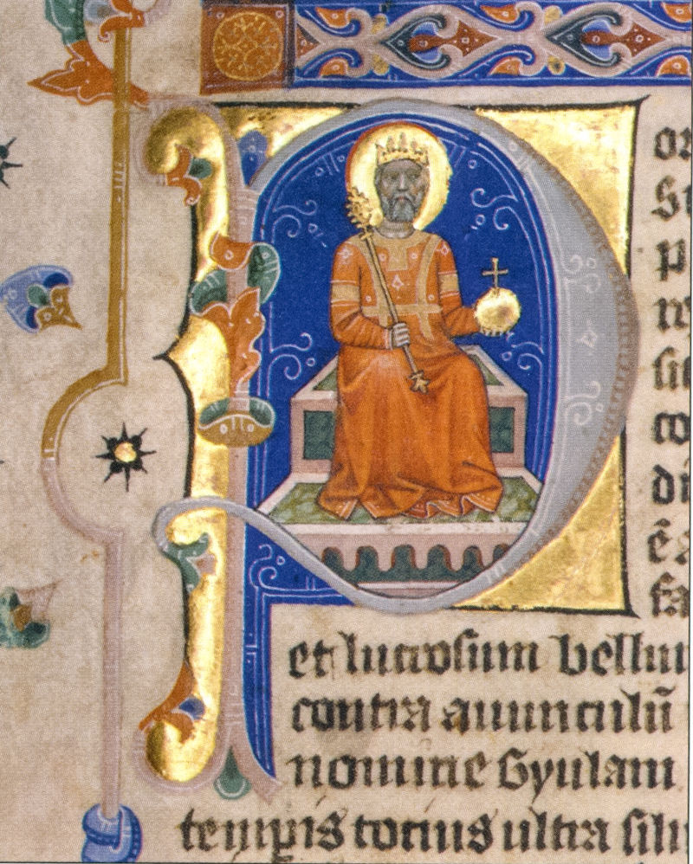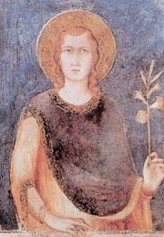
Szent István Szent Imre (https://hu.wikipedia.org/wiki/Szent_Imre#/media/File:SaintEmeric.jpg)
(https://hu.wikipedia.org/wiki/I._Istv%C3%A1n_magyar_kir%C3%A1ly#/media/File:Saint_Stephen_on_his_throne.jpg)

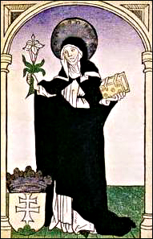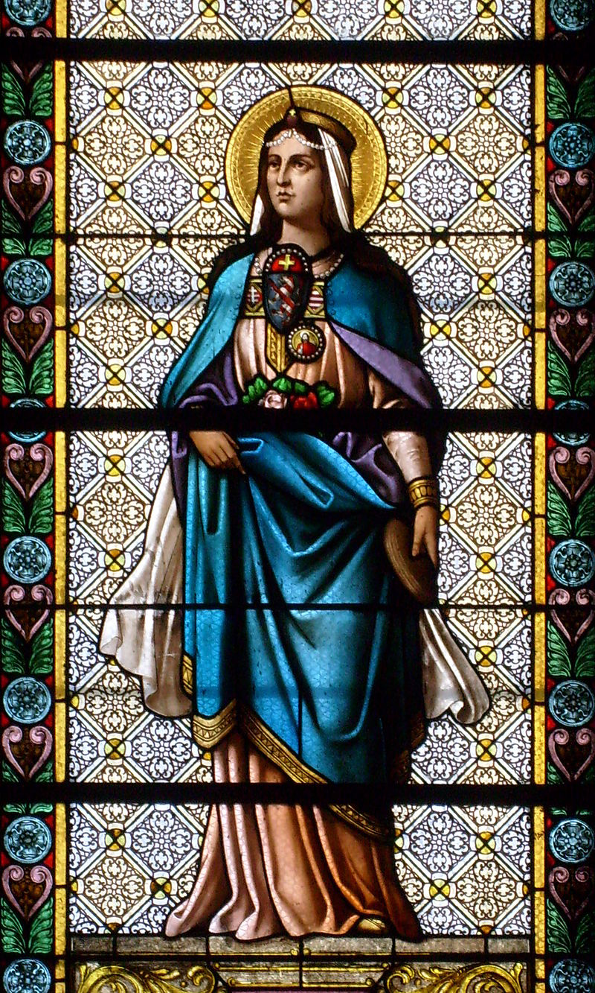
Szent Margit Szent Erzsébet (https://hu.wikipedia.org/wiki/%C3%81rp%C3%A1d-h%C3%A1zi_Szent_Erzs%C3%A9bet#/media/File:Biserica_Minoritilor_din_Cluj_-_Sf._Elisabeta_de_Thuringia.jpg

