Holy Land 2.
Find all the nine sanctuaries of the Holy Land.
Basilica of the Annunciation, Nazareth | 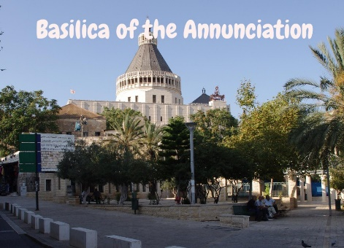
Church of the Nativity, Bethlehem | 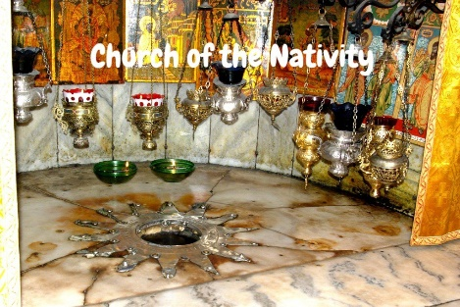
Shepherd's field | a church,dedicated to the Angels who had announced to the shepherds Jesus’s birth.
Wedding Church at Cana | 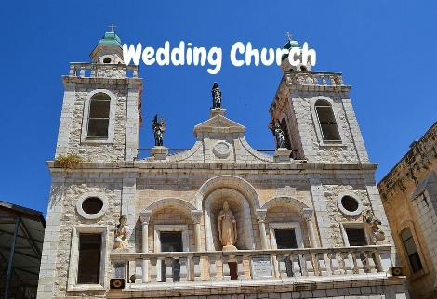
Mount of Beatitudes | 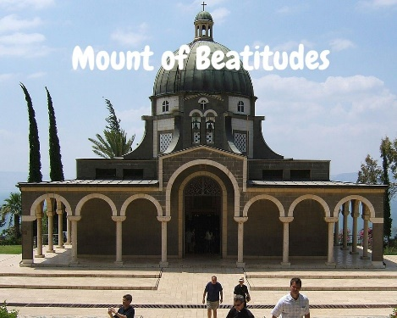
Basilica of the Transfiguration | it recalls how Jesus was transformed before his disciples Peter, James and John
the Sea of Galilee | 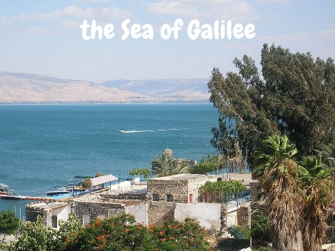
Mount of Olives | 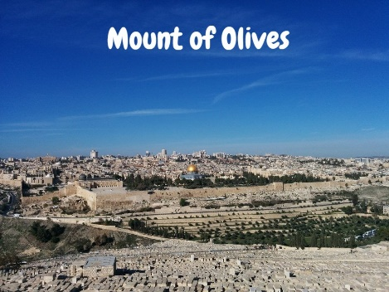
Holy Sepulcher | commemorates the hill of crucifixion and the tomb of Christ’s burial

