Christmas crossword
Complete the crossword. The words are related to Christmas.
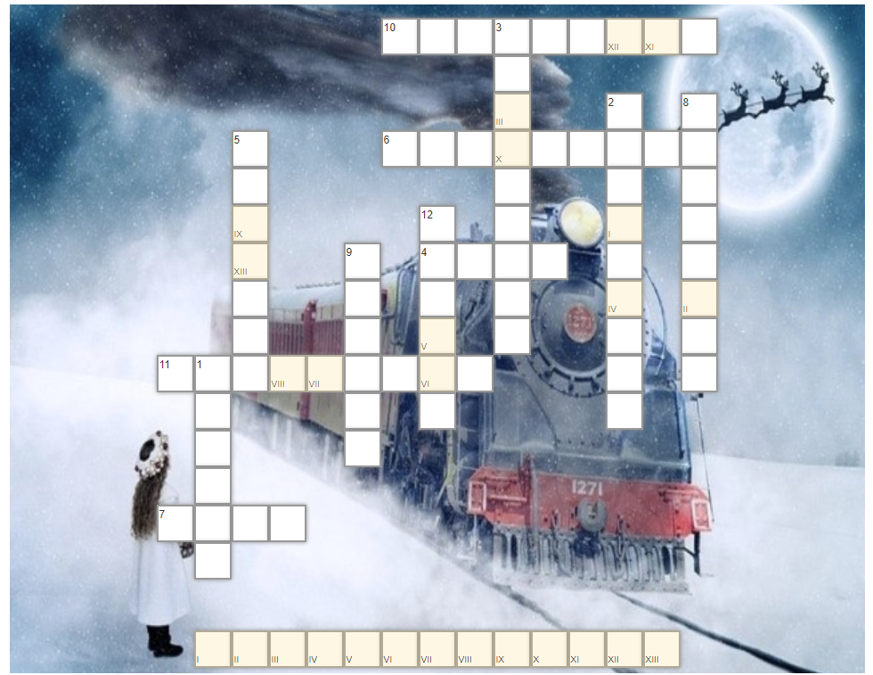

Down:
- We put this on presents.
- We hang these near the fireplace.
- Where Santa lives.
5. They visited baby Jesus.
8. Jesus was born in this city.
9. The father of Jesus
12. A famous snowman

Across:
- Santa lands his sleigh on this.
- Hang this plant to kiss under.
- One of the gifts of the wise men.
- They pull Santa's sleigh.
- We decorate the tree with these shiny balls.

Solution

