EISENACH
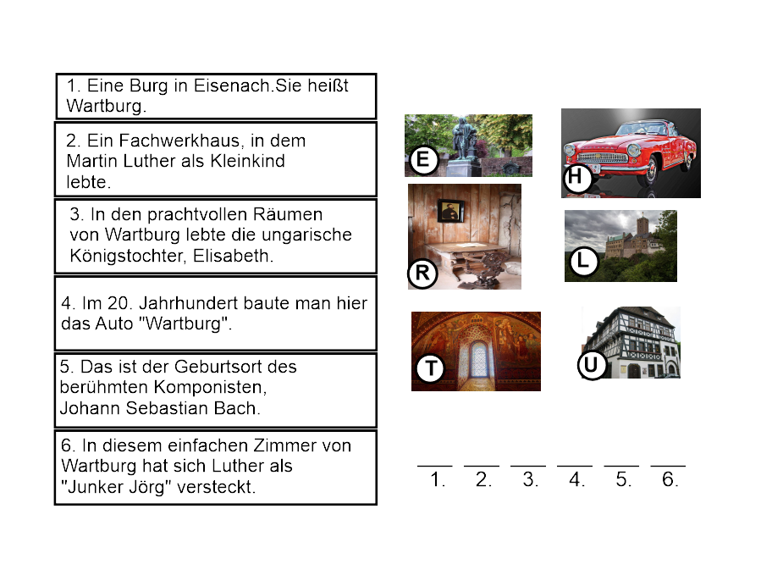

Források:
https://pixabay.com/en/thuringia-germany-castle-952388/
https://pixabay.com/en/thuringia-germany-castle-952388/
https://commons.wikimedia.org/wiki/File:Luther_haus_eisenach.jpg
https://pixabay.com/en/johann-sebastian-bach-composer-1282700/
https://pixabay.com/en/wartburg-castle-mosaic-fireplace-1033885/
https://pixabay.com/en/martin-luther-reformation-1305392/
https://pixabay.com/en/auto-oldtimer-wartburg-castle-1978187/

