**A szonett**

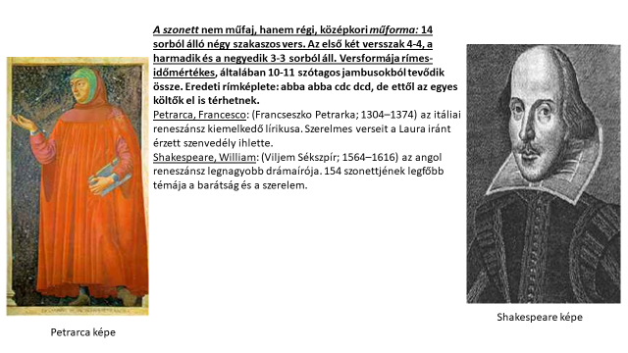**[1]**

1. https://upload.wikimedia.org/wikipedia/commons/8/8f/Petrarch_by_Bargilla.jpg

   https://hu.wikipedia.org/wiki/William_Shakespeare#/media/File:Shakespeare_Droeshout_1623_From_the_First_Folio_Edition.jpg